Homework 2

Joey Martinez

Jackson Watkins

J Goocher

5.1

A component-based architecture contains multiple loosely coupled components that interface with each other to provide a service. A service-oriented architecture contains pieces like a component-based architecture but each piece can act as a service or self-contained program to its clients.

5.2

A monolithic architecture could be used when creating a tic-tac-toe game in which a player can play with a computer player. Data like the high score can be stored on the user’s local computer. In this case, focus is more on building the tic-tac-toe game so there is no need to take on a multi-layer approach.

5.4

In the case of a chess game where two players can play each other over an internet connection, the client/server and two tier architectures would be most appropriate. Since two players would need to be able to play this game together, a server would need to host 2 players and hold the state of the chess game.

5.6

The ClassyDraw application should not use a database structure if it wants to only be a casual drawing tool. ClassyDraw, according to the text, should only be storing objects created in files on the local computer.

5.8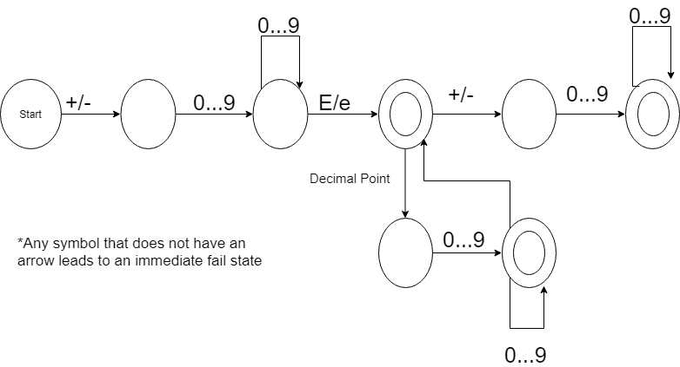

6.1

BackColor, FullColor, UpperLeft, Width, and Height are used by every class

LineThickness and DashStyle are used by the Rectangle, Ellipse, Star, and Line classes

FillColor is used by the Rectangle, Ellipse, and Star classes

NumPoints is used by the Star class

Font and String are used by the Text class

6.2

6.3



6.6

